Story 04 Add a Book - v2

Changes with respect to v0: see text in red

## Description

As a user

I want to add a book

So that it will be stored in the database

## Wireframe

Happy case:

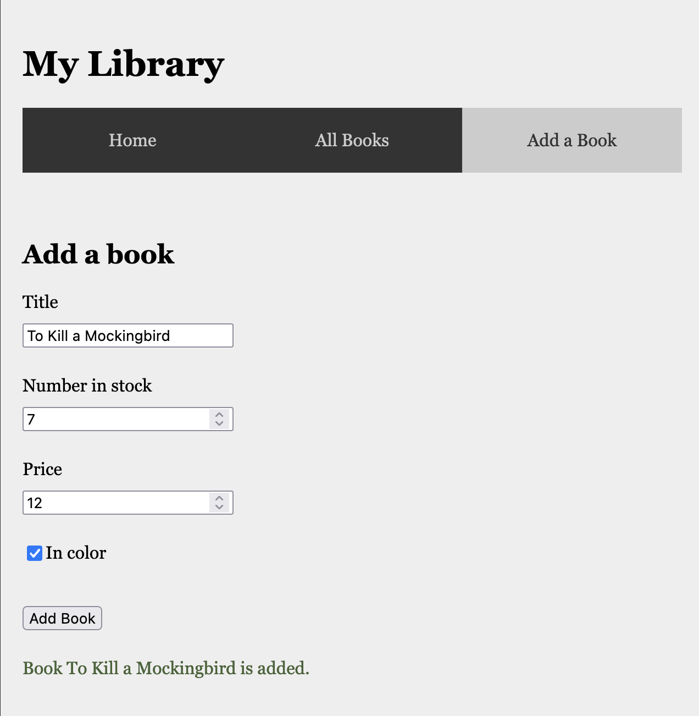

Unhappy case – Title is not unique:

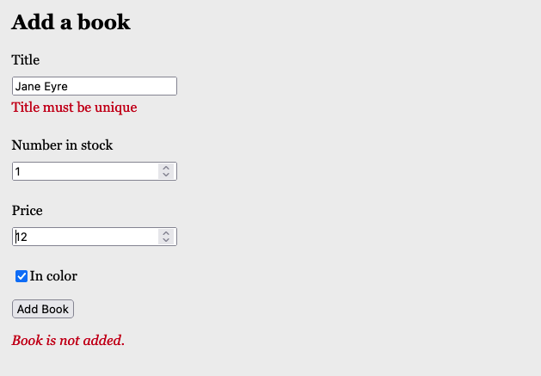

Unhappy case – Field errors

## Acceptance Criteria

* A book with given title can only be added once
* Book title is required and has length >3; the value of “number in Stock” is between 1 and 5 (including); the price must be positive; the default value for “inColor” is false.
* When a user fills in all fields and there is no book in the collection with the given title
  + A confirmation text with book title is shown below the form
  + the book is added to the database
  + the book is rendered on the overview page
* When a user tries to add a book with title that already is taken in the collection
  + the text “Book title must be unique” is displayed under the input field for “title”
  + the book is not added to the database
* If the user wants to add a book with invalid fields,
  + an appropriate error message is displayed under the corresponding input field.
  + The book is not added to the database

## Technical Requirements

## Output in Unhappy case has always response status 400 BAD REQUEST

|  |  |
| --- | --- |
| **Add a Book** | |
| **Request** | POST |
| **URL** | <http://localhost:8080/api/book/add> |
| **Input** | JSON object with fields “title” (String), “numberInStock” (int), “price” (double), “inColor” (Boolean) |
| **Output: Happy Case** | JSON book object with fields “id” (int), “title” (String), “numberInStock” (int), “price” (double), “inColor” (Boolean), “priceInDollar” (double) |
| **Output: Unhappy Case** | JSON error message (field corresponds to the field that generates the error)  "price": "Price must be positive"  "title": "Title is required"  "title": "Title must have at least 3 chars"  "title": "Title must be unique"  "numberInStock": "Number in stock must be between 1 and 5" |
| **Acceptance Criteria** | The given book is added to the h2 database when there is no book with the given title already in the collection. |

* Validation of input fields must be implemented as Hibernate validation.
* Validation of uniqueness of title must be implemented in the Service Class. When validation fails, a self written Service Exception is thrown and caught in the REST controller.
* The book is stored in a h2 database.